**VEER NARMAD SOUTH GUJRATUNIVERSITY,SURAT**

Second Year

Bachelor of Computer Application (S.Y.B.C.A)

**Semester- IV**



**Vimal Tormal Poddar BCA College**

File Submission

**405:pratical of Mobile Application**

**YEAR:2021-22**

**Submitted By**

**Gouda Suraj Pandav**

**Roll No:- 102**

**Exam No:-2019038887**

**Submitted To**

MS. ARTI JARIWALA

**Name: Gouda suraj**

**Class: SYBCA (SEM-4) Div.: B Roll No. 102 Exam Seat No. 2019038887**

**Subject : 405 – Mobile Application PRACTICAL FILE**

**Academic Year : 2021-22**

**INDEX**

| **Sr. No** | **Program Defination** | **Page No.** | **Signature** |
| --- | --- | --- | --- |
| 1. | **Create railway reservation utility** | 3 |  |
| 2. | **Create a user Registration page** | 12 |  |
| 3. | **Create an activity image slider** | 15 |  |
| 4. | **Create a food delivery application** | 18 |  |
| 5. | **Dart program to find factorial of number recursively** | 21 |  |
| 6 | **Dart program to find Armstrong number** | 22 |  |
| 7 | **Create mobile application for college system** | 25 |  |

**Assignment -1**

**Q-1** Create a Railway reservation utility for Android device which will accept detail such as train

name, reservation date, time, passenger name , Number of ticket, class of ticket (i.e.

SS,SL,CC,1A,2A,3A) etc.

Make use of proper UI: i.e. for name, address use edit text, for train name use single-

choice list dialog, for reservation date use date picker dialog, for reservation time use

time picker dialog, for passenger name and number of ticket use EditText, Number of

ticket only accepts numeric value. Perform following task:

Application have a next button, On click of next button entered detail should display to

the next activity.(Hints: pass all data to next activity using intent).

Answer:-

**Xml file:-**

<?xml version="1.0" encoding="utf-8"?>  
<RelativeLayout xmlns:android="http://schemas.android.com/apk/res/android"  
 xmlns:app="http://schemas.android.com/apk/res-auto"  
 xmlns:tools="http://schemas.android.com/tools"  
 android:layout_width="match_parent"  
 android:layout_height="match_parent"  
 android:background="@drawable/img"  
 android:id="@+id/r1"  
 tools:context=".MainActivity">  
  
  
 <TextView  
 android:id="@+id/b1"  
 android:layout_width="146dp"  
 android:layout_height="54dp"  
 android:layout_below="@+id/t1"  
 android:layout_marginTop="21dp"  
 android:text="Name:-"  
 android:textSize="30dp"  
 android:textStyle="bold"  
 tools:ignore="HardcodedText,SpUsage" />  
  
 <EditText  
 android:id="@+id/d1"  
 android:layout_width="253dp"  
 android:layout_height="52dp"  
 android:layout_below="@id/t1"  
 android:layout_alignParentEnd="true"  
 android:layout_alignParentRight="true"  
 android:layout_marginTop="24dp"  
 android:layout_marginEnd="5dp"  
 android:layout_marginRight="5dp" />  
  
 <TextView  
 android:id="@+id/b2"  
 android:layout_width="146dp"  
 android:layout_height="54dp"  
 android:layout_below="@+id/b1"  
 android:layout_marginTop="11dp"  
 android:text="Email i'd:-"  
 android:textSize="30dp"  
 android:textStyle="bold" />  
  
  
 <EditText  
 android:id="@+id/d2"  
 android:layout_width="248dp"  
 android:layout_height="51dp"  
 android:layout_below="@+id/d1"  
 android:layout_alignParentEnd="true"  
 android:layout_alignParentRight="true"  
 android:layout_marginTop="15dp"  
 android:layout_marginEnd="6dp"  
 android:layout_marginRight="6dp" />  
  
 <TextView  
 android:id="@+id/b3"  
 android:layout_width="146dp"  
 android:layout_height="54dp"  
 android:layout_below="@+id/b2"  
 android:layout_marginTop="9dp"  
 android:text="Mo. no.:-"  
 android:textSize="30dp"  
 android:textStyle="bold" />  
  
 <EditText  
 android:id="@+id/d3"  
 android:layout_width="253dp"  
 android:layout_height="55dp"  
 android:layout_below="@+id/d2"  
 android:layout_alignParentEnd="true"  
 android:layout_alignParentRight="true"  
 android:layout_marginTop="11dp"  
 android:layout_marginEnd="0dp"  
 android:layout_marginRight="0dp" />  
  
 <TextView  
 android:id="@+id/t1"  
 android:layout_width="wrap_content"  
 android:layout_height="59dp"  
 android:layout_alignParentEnd="true"  
 android:layout_alignParentRight="true"  
 android:layout_marginEnd="13dp"  
 android:layout_marginRight="13dp"  
 android:text="RAILWAY RESEVATION FORM"  
 android:textColor="@color/black"  
 android:textSize="28dp"  
 android:textStyle="bold"  
 app:layout_constraintBottom_toBottomOf="parent"  
 app:layout_constraintLeft_toLeftOf="parent"  
 app:layout_constraintRight_toRightOf="parent"  
 app:layout_constraintTop_toTopOf="parent" />  
  
 <TextView  
 android:layout_width="296dp"  
 android:layout_height="wrap_content"  
 android:layout_alignParentTop="true"  
 android:layout_alignParentBottom="true"  
 android:layout_marginTop="284dp"  
 android:layout_marginBottom="396dp"  
 android:text="Train name and no.:-"  
 android:textColor="@color/black"  
 android:textSize="30dp"  
 android:textStyle="bold" />  
  
 <Spinner  
 android:id="@+id/S"  
 android:layout_width="401dp"  
 android:layout_height="55dp"  
 android:layout_alignParentEnd="true"  
 android:layout_alignParentRight="true"  
 android:layout_alignParentBottom="true"  
 android:layout_marginEnd="6dp"  
 android:layout_marginRight="6dp"  
 android:layout_marginBottom="332dp" />  
  
 <TextView  
 android:layout_width="113dp"  
 android:layout_height="51dp"  
 android:layout_alignParentBottom="true"  
 android:layout_marginBottom="274dp"  
 android:text="From:-"  
 android:textColor="@color/black"  
 android:textSize="30dp"  
 android:textStyle="bold" />  
  
 <Spinner  
 android:id="@+id/S1"  
 android:layout_width="229dp"  
 android:layout_height="56dp"  
 android:layout_alignParentEnd="true"  
 android:layout_alignParentRight="true"  
 android:layout_alignParentBottom="true"  
 android:layout_marginEnd="14dp"  
 android:layout_marginRight="14dp"  
 android:layout_marginBottom="266dp" />  
  
 <TextView  
 android:layout_width="113dp"  
 android:layout_height="51dp"  
 android:layout_alignParentBottom="true"  
 android:layout_marginBottom="207dp"  
 android:text="To:-"  
 android:textColor="@color/black"  
 android:textSize="30dp"  
 android:textStyle="bold" />  
  
 <Spinner  
 android:id="@+id/S2"  
 android:layout_width="229dp"  
 android:layout_height="56dp"  
 android:layout_alignParentEnd="true"  
 android:layout_alignParentRight="true"  
 android:layout_alignParentBottom="true"  
 android:layout_marginEnd="18dp"  
 android:layout_marginRight="18dp"  
 android:layout_marginBottom="203dp" />  
  
 <TextView  
 android:layout_width="147dp"  
 android:layout_height="58dp"  
 android:layout_alignParentBottom="true"  
 android:layout_marginBottom="136dp"  
 android:text="All class:-"  
 android:textColor="@color/black"  
 android:textSize="30dp"  
 android:textStyle="bold" />  
  
 <Spinner  
 android:id="@+id/S3"  
 android:layout_width="229dp"  
 android:layout_height="56dp"  
 android:layout_alignParentEnd="true"  
 android:layout_alignParentRight="true"  
 android:layout_alignParentBottom="true"  
 android:layout_marginEnd="11dp"  
 android:layout_marginRight="11dp"  
 android:layout_marginBottom="140dp" />  
  
 <TextView  
 android:layout_width="97dp"  
 android:layout_height="53dp"  
 android:layout_alignParentBottom="true"  
 android:layout_marginBottom="75dp"  
 android:text="Date:-"  
 android:textColor="@color/black"  
 android:textSize="30dp"  
 android:textStyle="bold" />  
  
 <EditText  
 android:id="@+id/date"  
 android:layout_width="287dp"  
 android:layout_height="64dp"  
 android:layout_alignParentEnd="true"  
 android:layout_alignParentRight="true"  
 android:layout_alignParentBottom="true"  
 android:layout_marginEnd="-1dp"  
 android:layout_marginRight="-1dp"  
 android:layout_marginBottom="62dp"  
 android:hint="enter the journey date"  
 android:onClick="setDate"  
 android:textColor="@color/black" />  
  
 <Button  
 android:id="@+id/B1"  
 android:layout_width="wrap_content"  
 android:layout_height="wrap_content"  
 android:layout_alignParentEnd="true"  
 android:layout_alignParentRight="true"  
 android:layout_alignParentBottom="true"  
 android:layout_marginEnd="177dp"  
 android:layout_marginRight="177dp"  
 android:layout_marginBottom="9dp"  
 android:text="SUBMIT" />  
  
</RelativeLayout>

**MainActivity.java:-**

package com.example.a2railway_reservation;  
  
import androidx.appcompat.app.AppCompatActivity;  
import android.app.DatePickerDialog;  
import android.app.Dialog;  
import android.widget.DatePicker;  
import android.content.Intent;  
import android.view.View;  
import android.widget.Button;  
import android.widget.ArrayAdapter;  
import android.widget.EditText;  
import android.widget.RelativeLayout;  
import android.widget.Spinner;  
import android.os.Bundle;  
import android.widget.TextView;  
import android.widget.Toast;  
  
import java.util.Calendar;  
  
  
public class MainActivity extends AppCompatActivity {  
 private Calendar calendar;  
 private TextView dateView;  
 private int year, month, day;  
 RelativeLayout R1;  
 EditText T1, T2, T3, T4;  
 Spinner s, s1, s2, s3;  
 Button b1;  
  
 @Override  
 protected void onCreate(Bundle savedInstanceState) {  
 super.onCreate(savedInstanceState);  
 setContentView(R.layout.*activity_main*);  
 R1 = findViewById(R.id.*r1*);  
  
 T1 = findViewById(R.id.*d1*);  
 T2 = findViewById(R.id.*d2*);  
 T3 = findViewById(R.id.*d3*);  
  
 T4 = (EditText) findViewById(R.id.*date*);  
  
 s = findViewById(R.id.*S*);  
 s1 = findViewById(R.id.*S1*);  
 s2 = findViewById(R.id.*S2*);  
 s3 = findViewById(R.id.*S3*);  
  
 b1 = findViewById(R.id.*B1*);  
 b1.setOnClickListener(new View.OnClickListener() {  
 @Override  
 public void onClick(View view) {  
 String str = T1.getText().toString();  
 String str1 = T2.getText().toString();  
 String str2 = T3.getText().toString();  
 String str7 = T4.getText().toString();  
 String str3 = (String) s.getSelectedItem();  
 String str4 = (String) s1.getSelectedItem();  
 String str5 = (String) s2.getSelectedItem();  
 String str6 = (String) s3.getSelectedItem();  
 Intent i = new Intent(getApplicationContext(), MainActivity2.class);  
 i.putExtra("one", str);  
 i.putExtra("two", str1);  
 i.putExtra("three", str2);  
 i.putExtra("data", str3);  
 i.putExtra("four", str4);  
 i.putExtra("five", str5);  
 i.putExtra("six", str6);  
 i.putExtra("seven", str7);  
 startActivity(i);  
  
 }  
 });  
  
 String[] station = new String[]{"19046-Tapti Ganga Exp.", "18047-Ahemdabad To Barauni Exp.", "19045-Ganga Tapti Exp.", "12582-NDLS BSBE SF Exp.", "19483-Ali Bju Exp.", "12167-LLT BANARAS Exp."};  
 String[] station0 = new String[]{"Surat", "Ahemdabad", "Vadodara", "Pune", "Udhana", "Mumbai"};  
 String[] station1 = new String[]{"Varansi", "Alhabad", "Shahganj", "Jaunpur", "Bhusaval", "Itarsi"};  
 String[] station2 = new String[]{"SL", "3A", "2A", "1A", "CC", "EC", "2S", "3E", "FC", "GN"};  
 ArrayAdapter<String> adapter = new ArrayAdapter<String>(this, android.R.layout.*simple_dropdown_item_1line*, station);  
 ArrayAdapter<String> adapter0 = new ArrayAdapter<String>(this, android.R.layout.*simple_dropdown_item_1line*, station0);  
 ArrayAdapter<String> adapter1 = new ArrayAdapter<String>(this, android.R.layout.*simple_dropdown_item_1line*, station1);  
 ArrayAdapter<String> adapter2 = new ArrayAdapter<String>(this, android.R.layout.*simple_dropdown_item_1line*, station2);  
 s.setAdapter(adapter);  
 s1.setAdapter(adapter0);  
 s2.setAdapter(adapter1);  
 s3.setAdapter(adapter2);  
  
  
 //This part is datepicker  
 dateView = (TextView) findViewById(R.id.*date*);  
 calendar = Calendar.*getInstance*();  
 year = calendar.get(Calendar.*YEAR*);  
 month = calendar.get(Calendar.*MONTH*);  
 day = calendar.get(Calendar.*DAY_OF_MONTH*);  
 showDate(year, month + 1, day);  
 }  
 //This part is Date Picker  
 public void setDate(View view){  
 showDialog(999);  
 Toast.*makeText*(getApplicationContext(), "Choice is your",  
 Toast.*LENGTH_SHORT*)  
 .show();  
 }  
 protected Dialog onCreateDialog(int id){  
 if (id==999){  
 return new DatePickerDialog(this,myDateListener, year, month, day);  
 }  
 return null;  
 }  
  
 private DatePickerDialog.OnDateSetListener myDateListener = new  
 DatePickerDialog.OnDateSetListener() {  
 @Override  
 public void onDateSet(DatePicker arg0,int arg1, int arg2, int arg3) {  
  
 showDate(arg1, arg2+1, arg3);  
 }  
 };  
 private void showDate(int year, int month, int day) {  
 dateView.setText(new StringBuilder().append(day).append("/")  
 .append(month).append("/").append(year));  
  
 }  
}

**Xml file2:-**

<LinearLayout xmlns:android="http://schemas.android.com/apk/res/android"  
 xmlns:app="http://schemas.android.com/apk/res-auto"  
 xmlns:tools="http://schemas.android.com/tools"  
 android:layout_width="match_parent"  
 android:layout_height="match_parent"  
 android:orientation="vertical"  
 android:background="@drawable/img"  
 tools:context=".MainActivity2">  
  
 <RelativeLayout  
 android:layout_width="wrap_content"  
 android:layout_height="wrap_content">  
  
 </RelativeLayout>  
  
 <LinearLayout  
 android:layout_width="wrap_content"  
 android:layout_height="wrap_content">  
  
 <ImageView  
 android:id="@+id/imageView"  
 android:layout_width="match_parent"  
 android:layout_height="306dp"  
 android:labelFor="@+id/name"  
 app:srcCompat="@drawable/img_1" />  
  
 </LinearLayout>  
  
 <TextView  
 android:id="@+id/name"  
 android:layout_width="match_parent"  
 android:layout_height="wrap_content"  
 android:textSize="20dp"/>  
  
 <TextView  
 android:id="@+id/email"  
 android:layout_width="match_parent"  
 android:layout_height="wrap_content"  
 android:textSize="20dp"/>  
  
 <TextView  
 android:id="@+id/mn"  
 android:layout_width="match_parent"  
 android:layout_height="wrap_content"  
 android:textSize="20dp"/>  
  
 <TextView  
 android:id="@+id/t1"  
 android:layout_width="match_parent"  
 android:layout_height="wrap_content"  
 android:textSize="20dp"/>  
  
 <TextView  
 android:id="@+id/t2"  
 android:layout_width="match_parent"  
 android:layout_height="wrap_content"  
 android:textSize="20dp"/>  
  
 <TextView  
 android:id="@+id/t3"  
 android:layout_width="match_parent"  
 android:layout_height="wrap_content"  
 android:textSize="20dp"/>  
  
 <TextView  
 android:id="@+id/t4"  
 android:layout_width="match_parent"  
 android:layout_height="wrap_content"  
 android:textSize="20dp"/>  
  
 <TextView  
 android:id="@+id/date"  
 android:layout_width="match_parent"  
 android:layout_height="wrap_content"  
 android:textSize="20dp" />  
  
 <TextView  
 android:layout_width="325dp"  
 android:layout_height="40dp"  
 android:text="welcome to your jounney"  
 android:textSize="25dp"  
 android:textStyle="italic" />  
  
  
</LinearLayout>

**MainActivity2.java:-**

package com.example.a2railway_reservation;  
  
import androidx.appcompat.app.AppCompatActivity;  
  
import android.content.Intent;  
import android.os.Bundle;  
import android.widget.TextView;  
  
public class MainActivity2 extends AppCompatActivity {  
  
 TextView t1,t2,t3,t4,name,email,mn,date;  
 @Override  
 protected void onCreate(Bundle savedInstanceState) {  
 super.onCreate(savedInstanceState);  
 setContentView(R.layout.*activity_main2*);  
  
 t1 = (TextView)findViewById(R.id.*t1*);  
 t2 = (TextView)findViewById(R.id.*t2*);  
 t3 = (TextView)findViewById(R.id.*t3*);  
 t4 = (TextView)findViewById(R.id.*t4*);  
 name = (TextView)findViewById(R.id.*name*);  
 email = (TextView)findViewById(R.id.*email*);  
 mn = (TextView)findViewById(R.id.*mn*);  
 date = (TextView)findViewById(R.id.*date*);  
 Intent i = getIntent();  
 String str1 = i.getStringExtra("data");  
 String str2 = i.getStringExtra("four");  
 String str3 = i.getStringExtra("five");  
 String str4 = i.getStringExtra("six");  
 String Name = i.getStringExtra("one");  
 String Email = i.getStringExtra("two");  
 String Mn = i.getStringExtra("three");  
 String Date = i.getStringExtra("seven");  
 t1.setText("Train Name : " + str1);  
 t2.setText("From : " + str2);  
 t3.setText("To : " + str3);  
 t4.setText("Class " + str4);  
 name.setText("Name : " + Name);  
 email.setText("Email : " + Email);  
 mn.setText("Mobile No. : " + Mn);  
 date.setText("Date : " + Date);  
  
 }  
}

**output:-**

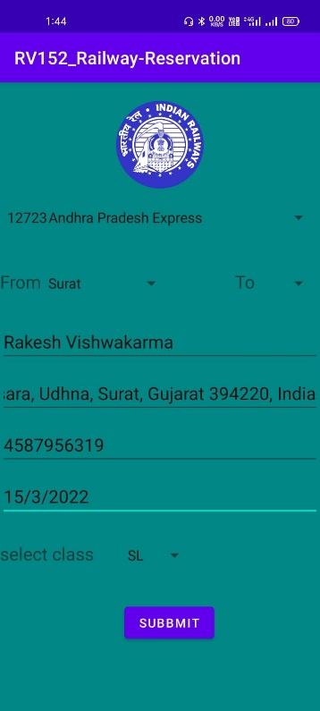 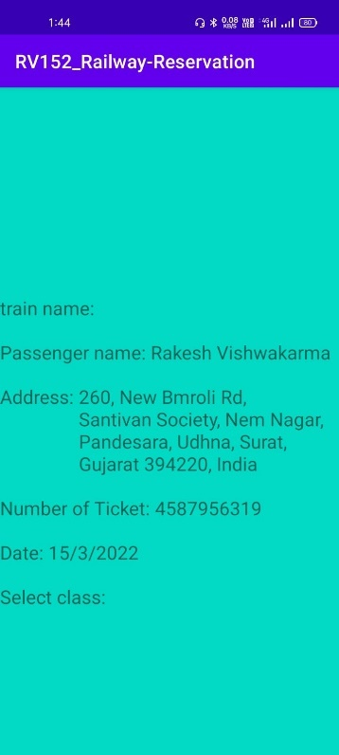

**Assignment -2**

**Q-1** Create a User Registration page including following Fields Name Email

( use TextWatcher to check user provide Email)

DOB (Use DateTimePicker Dialog)

City (Use Spinner to select City)

Course_Name (Use AutoCompleteTextView to suggest Course name like BCA, BBA, MCA, etc )

Provide Save Button Which shows Toast Message that User is Created.

Answer:-

**Xml file:-**

<?xml version="1.0" encoding="utf-8"?>  
<RelativeLayout xmlns:android="http://schemas.android.com/apk/res/android"  
 xmlns:app="http://schemas.android.com/apk/res-auto"  
 xmlns:tools="http://schemas.android.com/tools"  
 android:layout_width="match_parent"  
 android:layout_height="match_parent"  
 android:id="@+id/R1"  
 tools:context=".MainActivity">  
  
 <EditText  
 android:id="@+id/name"  
 android:layout_width="match_parent"  
 android:layout_height="wrap_content"  
 android:hint="Enter Name"  
 android:textSize="20dp"/>  
 <EditText  
 android:id="@+id/email"  
 android:layout_width="match_parent"  
 android:layout_height="wrap_content"  
 android:inputType="textEmailAddress"  
 android:hint="Enter E-mail"  
 android:textSize="20dp"  
 android:layout_below="@+id/name"/>  
 <EditText  
 android:id="@+id/date"  
 android:onClick="datepicker"  
 android:layout_width="match_parent"  
 android:layout_height="wrap_content"  
 android:hint="Select Date"  
 android:layout_below="@id/email"/>  
 <Spinner  
 android:id="@+id/city"  
 android:layout_width="match_parent"  
 android:layout_height="45dp"  
 android:layout_below="@id/date"  
 android:scrollbarSize="20dp"/>  
 <AutoCompleteTextView  
 android:id="@+id/coursename"  
 android:layout_width="match_parent"  
 android:layout_height="wrap_content"  
 android:layout_below="@id/city"  
 android:hint="Enter Course Name"  
 android:textSize="20dp"/>  
 <Button  
 android:id="@+id/btnsave"  
 android:layout_width="wrap_content"  
 android:layout_height="wrap_content"  
 android:text="Save"  
 android:layout_below="@id/coursename"  
 android:layout_centerHorizontal="true"/>

</RelativeLayout>

**MainActivity.java:-**

package com.example.user_registration_form;  
import androidx.appcompat.app.AppCompatActivity;  
import android.app.DatePickerDialog;  
import android.graphics.Color;  
import android.os.Bundle;  
import android.view.View;  
import android.widget.ArrayAdapter;  
import android.widget.AutoCompleteTextView;  
import android.widget.Button;  
import android.widget.DatePicker;  
import android.widget.EditText;  
import android.widget.Spinner;  
import android.widget.Toast;  
import java.util.Calendar;  
  
  
public class MainActivity extends AppCompatActivity {  
 EditText name,email,date;  
 Spinner city;  
 Button btnsave;  
 String[] course = {"BCA","BBA","MCA","B.COM","M.Com"};  
 @Override  
 protected void onCreate(Bundle savedInstanceState) {  
 super.onCreate(savedInstanceState);  
 setContentView(R.layout.*activity_main*);  
 date=(EditText) findViewById(R.id.*date*);  
 city=(Spinner)findViewById(R.id.*city*);  
 btnsave = (Button)findViewById(R.id.*btnsave*);  
 ArrayAdapter<String> adapter = new ArrayAdapter<String>(this,  
 android.R.layout.*select_dialog_item*,course);  
 AutoCompleteTextView coursename = (AutoCompleteTextView)findViewById(R.id.*coursename*);  
 coursename.setThreshold(1);  
 coursename.setAdapter(adapter);  
 coursename.setTextColor(Color.*BLACK*);  
 String [] cityname = new String[]{"Select City","Surat","Ahemdabad","Vadodara","Pune","Delhi","Mumbai"};  
 ArrayAdapter<String> adapter1 =new  
 ArrayAdapter<String>(this,android.R.layout.*simple_dropdown_item_1line*,cityname);  
 city.setAdapter(adapter1);  
 btnsave.setOnClickListener(new View.OnClickListener() {  
 @Override  
 public void onClick(View v) {  
 Toast.*makeText*(MainActivity.this, "User is Created", Toast.*LENGTH_SHORT*).show();  
 }  
 });  
 }  
 public void datepicker(View view) {  
 Calendar mcurrentDate = Calendar.*getInstance*();  
 int mYear = mcurrentDate.get(Calendar.*YEAR*);  
 int mMonth = mcurrentDate.get(Calendar.*MONTH*);  
 int mDay = mcurrentDate.get(Calendar.*DAY_OF_MONTH*);  
 DatePickerDialog mDatePicker;  
 mDatePicker = new DatePickerDialog(MainActivity.this, new  
 DatePickerDialog.OnDateSetListener() {  
 public void onDateSet(DatePicker datepicker, int selectedyear, int selectedmonth, int  
 selectedday) {  
  
 selectedmonth = selectedmonth + 1;  
 date.setText("" + selectedday + "/" + selectedmonth + "/" + selectedyear);  
 }  
 }, mYear, mMonth, mDay);  
 mDatePicker.show();  
  
 }  
}

**Output:-**

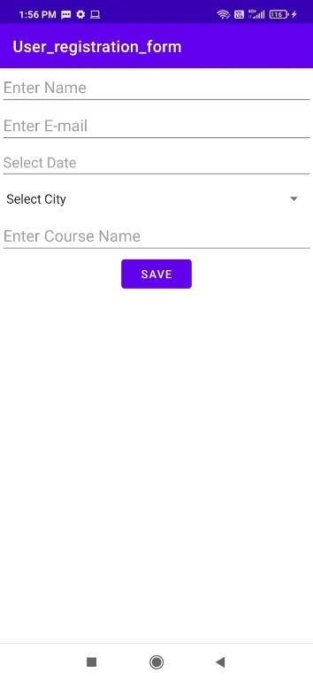 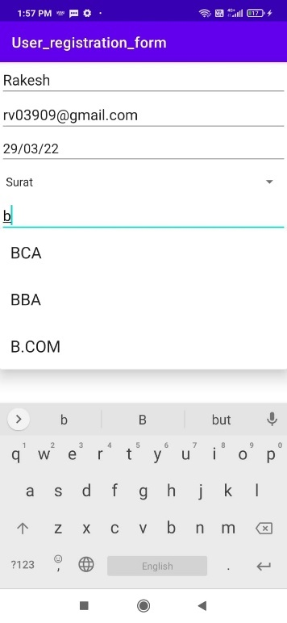 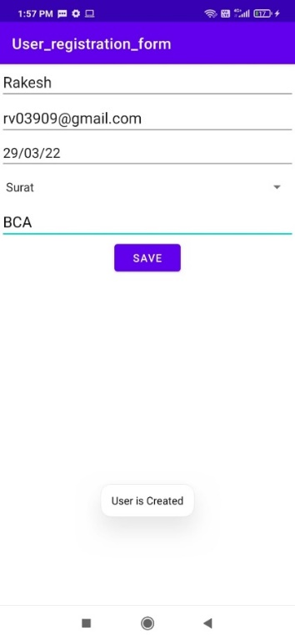

**Q-2** create an activity that has image slider on top portion of activity. below image slider display

the list of package tours available and when user selects a package on second activity the

details of the tour must be displayed along with images that can be switched on the click of button.

**Xml file:-**

<?xml version="1.0" encoding="utf-8"?>  
<RelativeLayout xmlns:android="http://schemas.android.com/apk/res/android"  
 xmlns:app="http://schemas.android.com/apk/res-auto"  
 xmlns:tools="http://schemas.android.com/tools"  
 android:layout_width="match_parent"  
 android:layout_height="match_parent"  
 tools:context=".MainActivity">  
  
 <TextView  
 android:layout_width="wrap_content"  
 android:layout_height="wrap_content"  
 android:text="ImageSwitcher Example"  
 android:id="@+id/textView"  
 android:layout_centerHorizontal="true"  
 android:textColor="#0000ff"  
 android:textSize="35dp" />  
 <ImageSwitcher  
 android:layout_width="wrap_content"  
 android:layout_height="wrap_content"  
 android:id="@+id/idImageSwitcher"  
 android:layout_below="@+id/textView"  
 android:layout_centerHorizontal="true"  
 android:layout_marginTop="16dp"  
 />  
 <LinearLayout  
 android:layout_width="match_parent"  
 android:layout_height="wrap_content"  
 android:layout_alignParentBottom="true"  
 android:orientation="horizontal">  
 <Button  
 android:layout_width="0dp"  
 android:layout_height="wrap_content"  
 android:text="Previous"  
 android:layout_weight="1"  
 android:id="@+id/idBtnPrevious"  
 />  
 <Button  
 android:layout_width="0dp"  
 android:layout_height="wrap_content"  
 android:text="Next"  
 android:layout_weight="1"  
 android:id="@+id/idBtnNext"  
 />  
</LinearLayout>  
  
</RelativeLayout>

**MainActivity.java:-**

package com.example.R_152_imageslider;  
import android.os.Bundle;  
import android.app.ActionBar;  
import androidx.appcompat.app.AppCompatActivity;  
import android.view.View;  
import android.widget.Button;  
import android.widget.ImageSwitcher;  
import android.widget.ImageView;  
import android.widget.Toast;  
import android.widget.ViewSwitcher;  
  
public class MainActivity extends AppCompatActivity {  
 private ImageSwitcher switcher;  
 private Button btnPrevious, btnNext;  
 private static final int[] *IMAGES* = {R.drawable.*img*, R.drawable.*img_1*, R.drawable.*img_2*,  
 R.drawable.*img_3*, R.drawable.*img_4*};  
 private int mPosition = -1;  
  
 @Override  
 protected void onCreate(Bundle savedInstanceState) {  
 super.onCreate(savedInstanceState);  
 setContentView(R.layout.*activity_main*);  
 btnPrevious = findViewById(R.id.*idBtnPrevious*);  
 btnNext = findViewById(R.id.*idBtnNext*);  
 switcher = findViewById(R.id.*idImageSwitcher*);  
 switcher.setFactory(new ViewSwitcher.ViewFactory() {  
 @Override  
 public View makeView() {  
 ImageView imageView = new ImageView(getApplicationContext());  
 imageView.setScaleType(ImageView.ScaleType.*FIT_CENTER*);  
 imageView.setLayoutParams(new ImageSwitcher.LayoutParams(ActionBar.LayoutParams.*WRAP_CONTENT*, ActionBar.LayoutParams.*WRAP_CONTENT*));  
 return imageView;  
 }  
 });  
 btnNext.setOnClickListener(new View.OnClickListener() {  
 @Override  
 public void onClick(View view) {  
 if (mPosition < *IMAGES*.length - 1) {  
 mPosition = mPosition + 1;  
 switcher.setBackgroundResource(*IMAGES*[mPosition]);  
 Toast.*makeText*(getApplicationContext(), "Position: " + mPosition, Toast.*LENGTH_SHORT*).show();  
 }  
 }  
 });  
 }  
}

**Output:-**

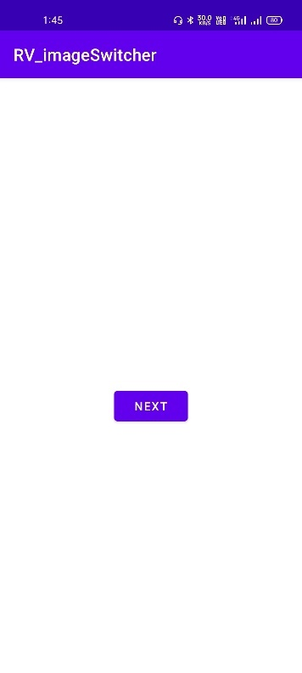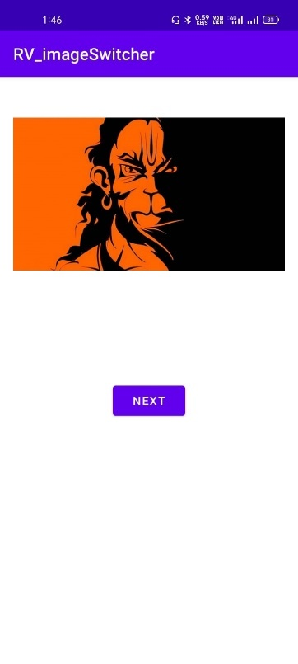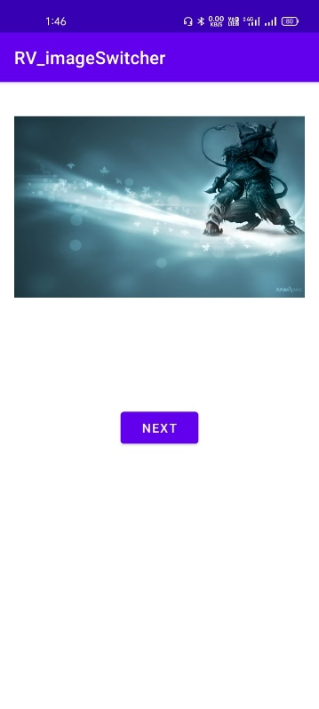 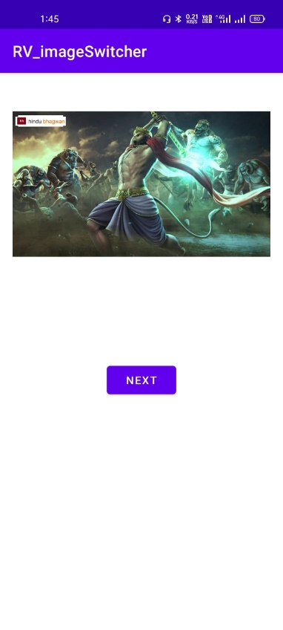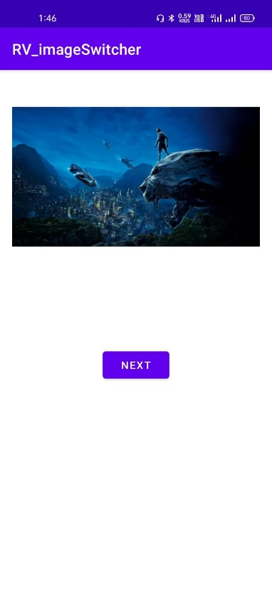

**Assignment -3**

**Q-1** Create a Food Delivery Application, showing Custom List of Food Items with its

respective price. Clicking of any Food Item, will open another layout with all the details

of the selected Item. In Detail layout use Image Slider component with multiple food.

**Xml file:-**

<?xml version="1.0" encoding="utf-8"?>  
<RelativeLayout xmlns:android="http://schemas.android.com/apk/res/android"  
 xmlns:app="http://schemas.android.com/apk/res-auto"  
 xmlns:tools="http://schemas.android.com/tools"  
 android:layout_width="match_parent"  
 android:layout_height="match_parent"  
 tools:context=".MainActivity">  
  
  
 <CheckBox  
 android:id="@+id/checkBox"  
 android:layout_width="92dp"  
 android:layout_height="42dp"  
 android:layout_alignParentTop="true"  
 android:layout_marginLeft="144dp"  
 android:layout_marginTop="44dp"  
 android:text="Pizza"  
 app:layout_constraintStart_toStartOf="parent"  
 app:layout_constraintTop_toTopOf="parent" />  
  
 <CheckBox  
 android:id="@+id/checkBox2"  
 android:layout_width="90dp"  
 android:layout_height="wrap_content"  
 android:layout_alignParentBottom="true"  
 android:layout_marginLeft="144dp"  
 android:layout_marginTop="28dp"  
 android:layout_marginBottom="577dp"  
 android:text="Coffee"  
 app:layout_constraintStart_toStartOf="parent"  
 app:layout_constraintTop_toBottomOf="@+id/checkBox" />  
  
 <CheckBox  
 android:id="@+id/checkBox3"  
 android:layout_width="90dp"  
 android:layout_height="wrap_content"  
 android:layout_alignParentBottom="true"  
 android:layout_marginLeft="144dp"  
 android:layout_marginTop="28dp"  
 android:layout_marginBottom="520dp"  
 android:text="Burger"  
 app:layout_constraintStart_toStartOf="parent"  
 app:layout_constraintTop_toBottomOf="@+id/checkBox2" />  
  
 <Button  
 android:id="@+id/button"  
 android:layout_width="wrap_content"  
 android:layout_height="wrap_content"  
 android:layout_alignParentBottom="true"  
 android:layout_marginLeft="144dp"  
 android:layout_marginTop="184dp"  
 android:layout_marginBottom="420dp"  
 android:text="Order"  
 app:layout_constraintStart_toStartOf="parent"  
 app:layout_constraintTop_toBottomOf="@+id/checkBox3" />  
  
</RelativeLayout>

**MainActivity.java:-**

package com.example.R_152_fooddelivery;  
  
  
import androidx.appcompat.app.AppCompatActivity;  
import android.os.Bundle;  
import android.view.View;  
import android.widget.Button;  
import android.widget.CheckBox;  
import android.widget.Toast;  
  
public class MainActivity extends AppCompatActivity {  
 CheckBox pizza,coffe,burger;  
 Button buttonOrder;  
 @Override  
 protected void onCreate(Bundle savedInstanceState) {  
 super.onCreate(savedInstanceState);  
 setContentView(R.layout.*activity_main*);  
 addListenerOnButtonClick();  
 }  
 public void addListenerOnButtonClick(){  
 //Getting instance of CheckBoxes and Button from the activty_main.xml file  
 pizza=(CheckBox)findViewById(R.id.*checkBox*);  
 coffe=(CheckBox)findViewById(R.id.*checkBox2*);  
 burger=(CheckBox)findViewById(R.id.*checkBox3*);  
 buttonOrder=(Button)findViewById(R.id.*button*);  
  
 //Applying the Listener on the Button click  
 buttonOrder.setOnClickListener(new View.OnClickListener(){  
  
 @Override  
 public void onClick(View view) {  
 int totalamount=0;  
 StringBuilder result=new StringBuilder();  
 result.append("Selected Items:");  
 if(pizza.isChecked()){  
 result.append("\nPizza 100Rs");  
 totalamount+=100;  
 }  
 if(coffe.isChecked()){  
 result.append("\nCoffe 50Rs");  
 totalamount+=50;  
 }  
 if(burger.isChecked()){  
 result.append("\nBurger 120Rs");  
 totalamount+=120;  
 }  
 result.append("\nTotal: "+totalamount+"Rs");  
 //Displaying the message on the toast  
 Toast.*makeText*(getApplicationContext(), result.toString(), Toast.*LENGTH_LONG*).show();  
 }  
  
 });  
 }  
}

**Output:-**

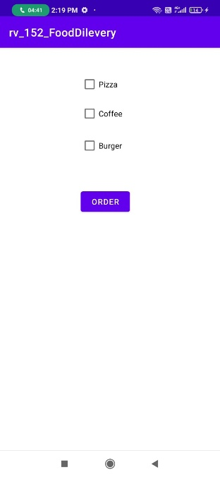 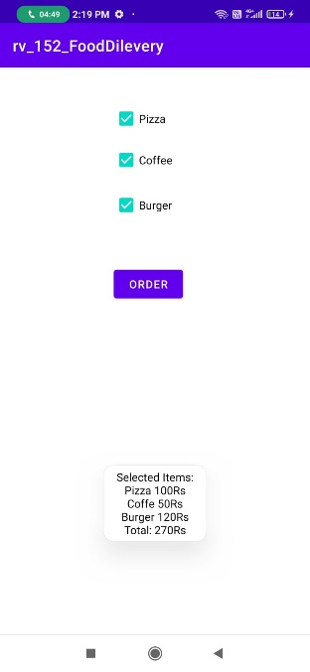

**Q-2** Dart program to find factorial of a number recursively.

**Recursive function :-**

function_name(){

function_name();

}

**Dart programme:-**

*import* 'dart:io';

findFactorial(int no) {

*if* (no == 1) {

*return* 1;

}

*return* no * findFactorial(no - 1);

}

main() {

print("Enter a number : ");

*var* no = int.parse(stdin.readLineSync());

print('Factorial of $no is ${findFactorial(no)}');

}

### Output :-

Enter a number :

4

Factorial of 4 is 24

**Q-3** Dart program to find Armstrong number. E.g 153

import 'dart:io';

import 'dart:math';

void main(){

int? num;

print('Enter A Number to check ARMSTRONG or NOT ARMSTRONG NUMBER');

// user will enter a number to check

num = int.parse(stdin.readLineSync()!);

// user entered number is passed to function

print('________________________________________-');

for(int i = 0;i<=num;i++)

{

//if i is arm strong then print it else don't

if(isArmString(i))

{

print(i);

}

}

}

//a function to check arm strong

bool isArmString(int number){

//initial some variable

int temp,digits =0, last = 0, sum = 0;

//assign user entered number to temp variable

temp = number;

// loop execute until temp is 0 and increment digits by 1 each loop

while(temp>0){

temp = temp~/10;

digits++;

}

//reset temp to user entered number

temp = number;

//another loop for getting sum

while(temp>0){

last = temp % 10;

sum = sum + pow(last, digits) as int;

temp = temp~/10;

}

// now if number and sum are equal its a arm strong number

if(number == sum){

return true;

}else{

return false;

}

}

**Output:-**

Ps c:\User\shani\Desktop>dart Armstrong.dart

Enter A Number to check ARMSTRONG or NOT AMRSTRONG Number

1000

-----------------------------------------------------------

0

1

2

3

4

5

6

7

8

9

153

370

371

487

Ps c:\User\shani\Desktop>[]

**Assignment -4**

**Q-1** Create Mobile Application for college System.

1.) Which contains following functionality.

1. Login and Registration Screen

2. Subject List with search view.

import 'package:R_152_college/login_page.dart';

import 'package:flutter/material.dart';

void main() {

runApp(const MyApp());

}

class MyApp extends StatelessWidget {

const MyApp({Key? key}) : super(key: key);

@override

Widget build(BuildContext context) {

return MaterialApp(

title: 'Flutter Demo',

debugShowCheckedModeBanner: false, theme:

ThemeData(

primarySwatch: Colors.purple,

elevatedButtonTheme: ElevatedButtonThemeData(

style: ElevatedButton.styleFrom(

primary: Colors.deepPurple,

elevation: 8,

shape: RoundedRectangleBorder(

borderRadius: BorderRadius.circular(25)),

),

),

appBarTheme: const AppBarTheme(

backgroundColor: Colors.deepPurple,

foregroundColor: Colors.white,

),

inputDecorationTheme: InputDecorationTheme(

enabledBorder: OutlineInputBorder(

borderRadius: BorderRadius.circular(25),

borderSide: const BorderSide(color: Colors.white, width: 2),

),

border: OutlineInputBorder(

borderRadius: BorderRadius.circular(25),

borderSide: const BorderSide(color: Colors.white, width: 2)),

filled: true,

fillColor: Colors.white,

)),

home: const LoginPage());

}

}

**home_page.dart:-**

import 'package:flutter/material.dart';

class HomePage extends StatelessWidget {

const HomePage({Key? key}) : super(key: key);

@override

Widget build(BuildContext context) {

return Scaffold(

appBar: AppBar(

title: const Text("Home Screen"),

),

body: SizedBox(

width: double.infinity,

child: Column(

crossAxisAlignment: CrossAxisAlignment.center,

children: [

const SizedBox(

height: 16,

),

ElevatedButton(

onPressed: () {

showSearch(

context: context, delegate: CustomSearchDelegate());

},

child: SizedBox(

width: 150,

child: Row(

mainAxisAlignment: MainAxisAlignment.center,

children: const [

Text("Seach Subjects"),

SizedBox(

width: 20,

),

Icon(Icons.search),

],

),

))

],

),

),

);

}

}

class CustomSearchDelegate extends SearchDelegate {

final List<String> _subjects = [

"Python",

"Java",

"Mobile Application Development",

"Vb.net",

"Information System",

"IOT"

];

@override

List<Widget>? buildActions(BuildContext context) {

return [

IconButton(

onPressed: () {

query = "";

},

icon: const Icon(Icons.clear_sharp))

];

}

@override

Widget? buildLeading(BuildContext context) {

return IconButton(

onPressed: () {

close(context, null);

},

icon: const Icon(Icons.arrow_back));

}

@override

Widget buildResults(BuildContext context) {

List<String> matchQuery = [];

123-JATIN NANDANWAR 47

for (var item in _subjects) {

if (item.toUpperCase().contains(query.toUpperCase())) {

matchQuery.add(item);

}

}

return ListView.builder(

itemCount: matchQuery.length,

itemBuilder: (context, index) {

var result = matchQuery[index];

return ListTile(

title: Text(result),

);

},

);

}

@override

Widget buildSuggestions(BuildContext context) {

List<String> matchQuery = [];

for (var item in _subjects) {

if (item.toUpperCase().contains(query.toUpperCase())) {

matchQuery.add(item);

}

}

return ListView.builder(

itemCount: matchQuery.length,

itemBuilder: (context, index) {

var result = matchQuery[index];

return ListTile(

title: Text(result),

);

},

);

}

}

**login_page.dart:-**

import 'package:j_123_college/registration_page.dart';

import 'package:flutter/material.dart';

import 'package:flutter_svg/flutter_svg.dart';

import 'home_page.dart';

import 'text_input_card.dart';

class LoginPage extends StatelessWidget {

const LoginPage({Key? key}) : super(key: key);

@override

Widget build(BuildContext context) {

final width = MediaQuery.of(context).size.width;

final height = MediaQuery.of(context).size.height;

return Scaffold(

backgroundColor: Colors.white,

body: SafeArea(

child: SingleChildScrollView(

child: Column(

children: [

SizedBox(

height: height * 0.5,

// color: Colors.black,

child: SvgPicture.asset("assets/svgs/reading.svg"),

),

const SizedBox(

height: 16,

),

Padding(

padding: const EdgeInsets.symmetric(horizontal: 16),

child: Form(

child: Column(

children: [

TextInputCard(

child: TextFormField(

decoration: const InputDecoration(

labelText: "Username",

),

),

),

const SizedBox(

height: 10,

),

TextInputCard(

child: TextFormField(

decoration: const InputDecoration(

labelText: "Password",

),

)),

const SizedBox(

height: 10,

),

SizedBox(

width: width - 50,

height: 45,

child: ElevatedButton(

onPressed: () {

Navigator.of(context).push(

MaterialPageRoute(

builder: (context) => const HomePage()),

);

},

child: const Text("Login"),

style: ElevatedButton.styleFrom(

// primary: Colors.white,

elevation: 8,

shape: RoundedRectangleBorder(

borderRadius: BorderRadius.circular(25))),

),

),

Row(

mainAxisAlignment: MainAxisAlignment.center,

children: [

const Text("Don't have an account.?"),

TextButton(

onPressed: () {

Navigator.of(context).push(MaterialPageRoute(

builder: (context) => RegistrationPage(),

));

},

child: const Text("Sign Up"))

],

)

],

)),

),

],

),

),

),

);

}

}

**registration_page.dart:-**

import 'home_page.dart';

import 'text_input_card.dart';

import 'package:flutter/material.dart';

class RegistrationPage extends StatelessWidget {

// List<String> details = [];

final TextEditingController _fullName = TextEditingController();

final TextEditingController _userName = TextEditingController();

final TextEditingController _email = TextEditingController();

final TextEditingController _mobile = TextEditingController();

final TextEditingController _password = TextEditingController();

RegistrationPage({Key? key}) : super(key: key);

@override

Widget build(BuildContext context) {

var size = MediaQuery.of(context).size;

double _height = size.height;

double _width = size.width;

return Scaffold(

appBar: AppBar(

title: const Center(

child: Text('Registration'),

),

),

body: Container(

padding: const EdgeInsets.symmetric(horizontal: 12, vertical: 12),

color: Colors.white,

height: _height,

width: _width,

child: SingleChildScrollView(

child: Form(

child: Column(

mainAxisAlignment: MainAxisAlignment.center,

children: [

TextInputCard(

child: TextFormField(

controller: _fullName,

decoration: const InputDecoration(

label: Text('Fullname'),

),

),

),

SizedBox(

height: _height * 0.01,

),

TextInputCard(

child: TextFormField(

controller: _userName,

decoration: const InputDecoration(

label: Text('User Name'),

suffixIcon: Icon(Icons.person),

),

),

),

SizedBox(

height: _height * 0.01,

),

TextInputCard(

child: TextFormField(

controller: _email,

keyboardType: TextInputType.emailAddress,

decoration: const InputDecoration(

label: Text('Email'), suffixIcon: Icon(Icons.email)),

),

),

SizedBox(

height: _height * 0.01,

),

TextInputCard(

child: TextFormField(

keyboardType: TextInputType.number,

controller: _mobile,

decoration: const InputDecoration(

label: Text('Mobile Number'),

suffixIcon: Icon(Icons.phone),

),

),

),

SizedBox(

height: _height * 0.01,

),

TextInputCard(

child: TextFormField(

obscureText: true,

decoration: const InputDecoration(

label: Text('Password'), suffixIcon: Icon(Icons.lock)),

controller: _password,

),

),

SizedBox(

height: _height * 0.03,

),

SizedBox(

height: 45,

width: _width - 50,

child: ElevatedButton(

onPressed: () {

Navigator.of(context).push(

MaterialPageRoute(

builder: (context) => const HomePage()),

);

ScaffoldMessenger.of(context).showSnackBar(const SnackBar(

content: Text("Successfully Registered")));

},

child: const Text('Register'),

),

),

],

),

),

),

),

);

}

}

**text_input_card.dart:-**

import 'package:flutter/material.dart';

class TextInputCard extends StatelessWidget {

final Widget child;

const TextInputCard({

Key? key,

required this.child,

}) : super(key: key);

@override

Widget build(BuildContext context) {

return SizedBox(

height: 55,

child: Card(

elevation: 8,

// color: Colors.purple,

shape: RoundedRectangleBorder(borderRadius: BorderRadius.circular(25)),

child: child

),

);

}

}

**OUTPUT :-**

